**REACT**

**Cricketapp**

**App.js**

import React from "react";

import ListofPlayers from "./ListofPlayers";

import Scorebelow70 from "./Scorebelow70";

import { OddPlayers, EvenPlayers } from "./IndianPlayers";

import ListofIndianPlayers from "./ListofIndianPlayers";

function Home() {

  var flag = true;

  const players = [

    { name: "Jack", score: 50 },

    { name: "Michael", score: 70 },

    { name: "John", score: 40 },

    { name: "Ann", score: 61 },

    { name: "Elisabeth", score: 61 },

    { name: "Sachin", score: 95 },

    { name: "Dhoni", score: 100 },

    { name: "Virat", score: 84 },

    { name: "Jadeja", score: 64 },

    { name: "Raina", score: 75 },

    { name: "Rohit", score: 80 },

  ];

  const IndianTeam = [

    "Sachin",

    "Dhoni",

    "Virat",

    "Rohit",

    "Yuvaraj",

    "Raina",

  ];

  const T20Players = ["First Player", "Second Player","Third Player"];

  const RanjiPlayers = ["Fourth Player", "Fith Player","Sixth Player"];

  const IndianPlayers = [...T20Players, ...RanjiPlayers];

  if (flag === true) {

    return (

      <div>

        <h2>List of Players</h2>

        <ListofPlayers players={players} />

        <hr/>

        <h2>List of Players having Scores Less than 70</h2>

        <Scorebelow70 players={players} />

      </div>

    );

  }  else {

  return (

    <div>

      <h2>Odd Players</h2>

      <OddPlayers IndianTeam={IndianTeam} />

      <hr/>

      <h2>Even Players</h2>

      <EvenPlayers IndianTeam={IndianTeam} />

      <hr/>

      <h2>List of Indian Players Merged</h2>

      <ListofIndianPlayers IndianPlayers={IndianPlayers} />

    </div>

  );

}

}

export default Home;

**IndianPlayers.js**

import React from "react";

export function OddPlayers({ IndianTeam }) {

  const [first, , third, , fifth] = IndianTeam;

  return (

    <ul>

      <li>First : {first}</li>

      <li>Third : {third}</li>

      <li>Fifth : {fifth}</li>

    </ul>

  );

}

export function EvenPlayers({ IndianTeam }) {

  const [, second, , fourth, , sixth] = IndianTeam;

  return (

    <ul>

      <li>Second : {second}</li>

      <li>Fourth : {fourth}</li>

      <li>Sixth : {sixth}</li>

    </ul>

  );

}

**ListofIndianPlayers.js**

function ListofIndianPlayers({ IndianPlayers }) {

  return (

    <ul>

      {IndianPlayers.map((player, index) => (

        <li key={index}> Mr. {player}</li>

      ))}

    </ul>

  );

}

export default ListofIndianPlayers;

**Scorebelow70.js**

function Scorebelow70({ players }) {

  const filtered = players.filter((player) => player.score <= 70);

  return (

    <ul>

      {filtered.map((player, index) => (

        <li key={index}>

          Mr. {player.name}  {player.score}

        </li>

      ))}

    </ul>

  );

}

export default Scorebelow70;

**ListofPlayers.js**

function ListofPlayers({ players }) {

  return (

    <ul>

      {players.map((player, index) => (

        <li key={index}>

          Mr. {player.name} {player.score}

        </li>

      ))}

    </ul>

  );

}

export default ListofPlayers;

**OUTPUT**

**flag=true**

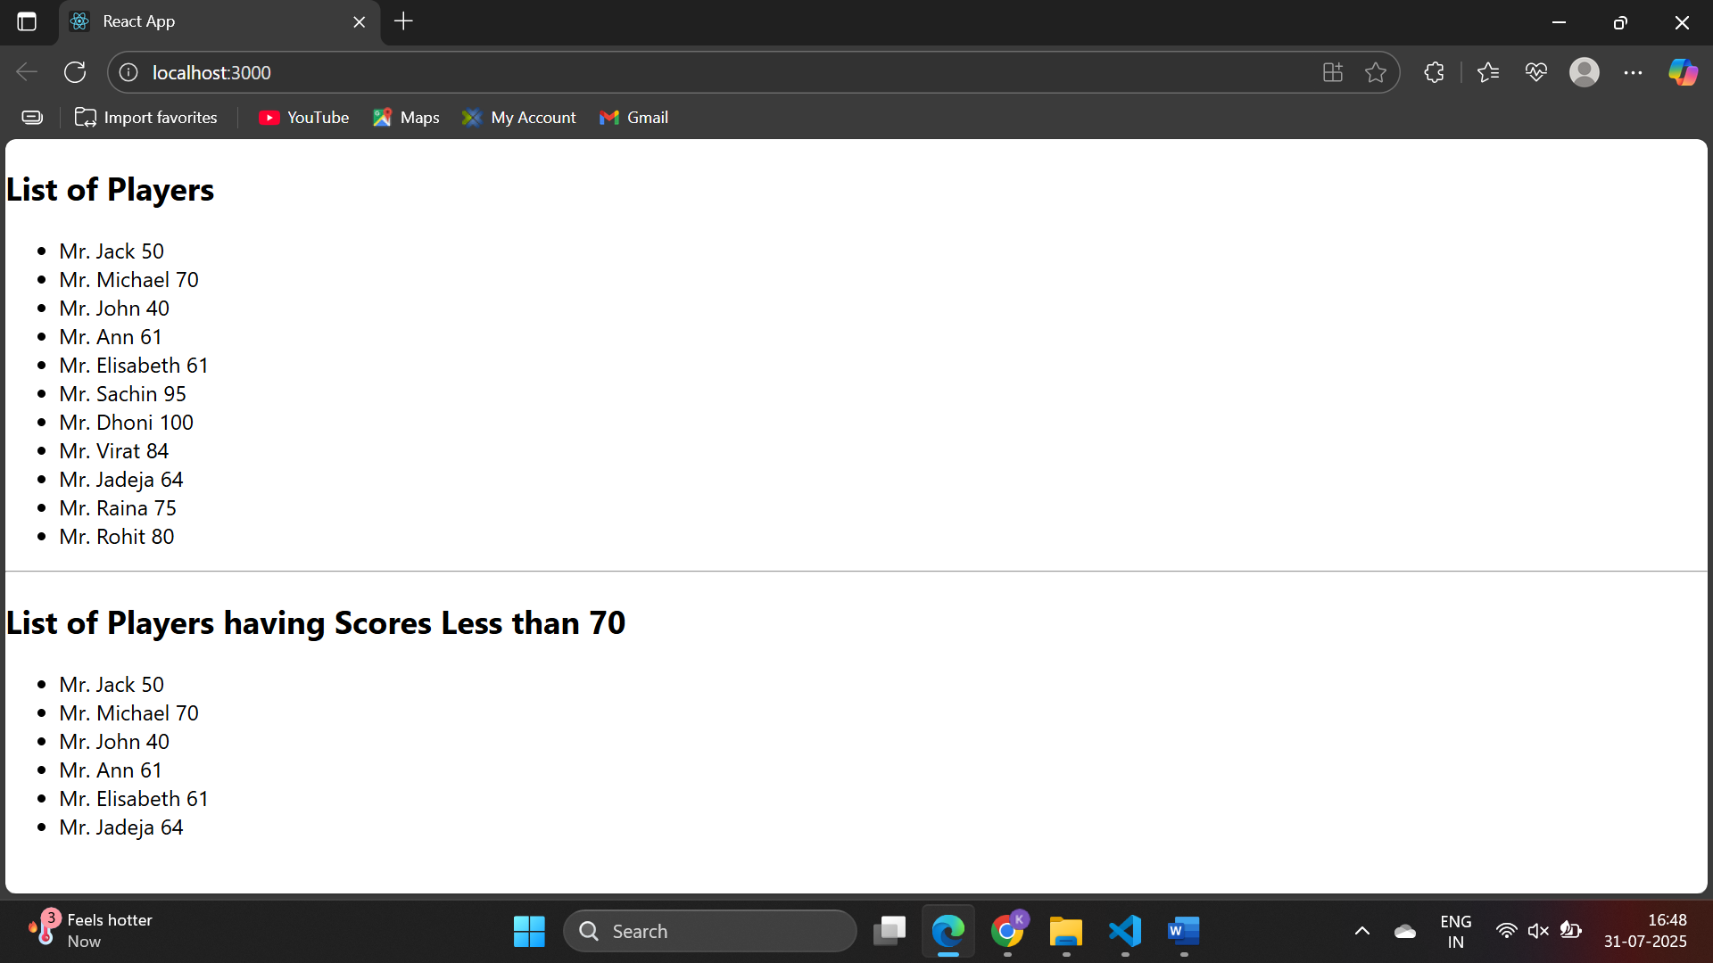

**Flag=false**

